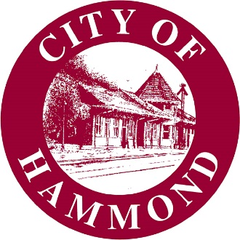

RESOLUTION OF THE HAMMOND CITY COUNCIL

NO.

A resolution (1) supporting the submission of a $150,000 NEA Our Town grant application to install public art in the 3 roundabouts along Southwest Railroad Avenue (US 51 Business) at I-12 and Club Deluxe Road; and (2) supporting a cash match of up to $150,000.

WHEREAS, the National Endowment for the Arts's Our Town grant program supports local efforts to enhance quality of life and opportunity and to transform communities into lively, beautiful, and resilient places—with the arts at their core;

WHEREAS, NEA Our Town grants may be used for public art projects that improve public spaces—celebrating the distinctive character and quality of communities;

WHEREAS, the State of Louisiana, the City of Hammond, and private partners have joined in the creation of a Gateway to Hammond along Southwest Railroad Avenue (US 51 Business) at I-12 and Club Deluxe Road to calm traffic, attract and welcome travelers to our storied city, and celebrate its distinctive character, liveliness, beauty, and resilience as a "Crossroads of the South" and believe public art in this space will further these objectives; and

WHEREAS, the City is eligible and desires to apply for a $150,000 NEA Our Town grant for this purpose and is prepared to provide a cash match of up to $150,000 to the project.

NOW, THEREFORE BE IT RESOLVED THAT THE CITY OF HAMMOND HEREBY

- supports the submission of a 150,000 NEA Our Town grant application to install public art in the 3 roundabouts along Southwest Railroad Avenue (US 51 Business) at I-12 and Club Deluxe Road; and

- supports a cash match of up to $150,000.

Approved and adopted this _____ day of _________________________, 20_____.

I, the undersigned Clerk of the Council, hereby certify that the foregoing Resolution was duly adopted by the Hammond City Council following roll call vote:

Yeas: ___ Nays: ___ Absent: ___

Tonia Banks Johnny Blount
Hammond City Council Clerk Hammond City Council President

