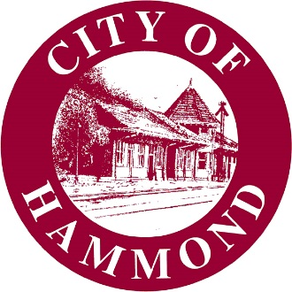

RESOLUTION OF THE HAMMOND CITY COUNCIL

NO. | 22-1027-07

A resolution supporting the submission of a grant application for $50,000 to the Community Water Enrichment Fund for improvements to the City’s water system.

WHEREAS, the purpose of the Community Water Enrichment Fund (CWEF), administered by the Louisiana Office of Community Development, is to provide funding to local governments for rehabilitation, improvement, and construction projects for community water systems to provide safe and clean drinking water;

WHEREAS, the City, a local government of more than 5,000 residents, is eligible to apply for $50,000 in CWEF funds; and

WHEREAS, the City desires to apply for such funds for improvements to its water system to continue to provide for safe and clean drinking water for Hammond's residents, workforce, and visitors.

NOW, THEREFORE BE IT RESOLVED THAT THE CITY OF HAMMOND HEREBY

supports the submission of a grant application for $50,000 to the Community Water Enrichment Fund for improvements to the City’s water system.

Approved and adopted this |  | day of |  | , 2022.

I, the undersigned Clerk of the Council, hereby certify that the foregoing Resolution was duly adopted by the Hammond City Council following roll call vote: Carlee Gonzales (), Kip Andrews (), Sam DiVittorio (), Devon Wells (), Steve Leon ().

Yeas: |  | Nays: |  | Absent:

Lisa Cockerham Kip Andrews
Hammond City Council Clerk Hammond City Council President

