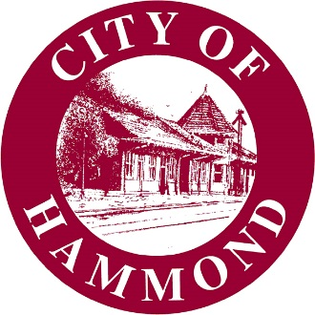

RESOLUTION OF THE HAMMOND CITY COUNCIL

NO. | 22-1027-08

A resolution authorizing Lisa Cockerham, Hammond City Council Clerk, to certify authorized signatories and signatures for the Fiscal Year 2022–23 Local Government Assistance Program and Community Water Enrichment Fund.

WHEREAS, a grantee under the Local Government Assistance Program and/or Community Water Enrichment Fund, both administered by the Louisiana Office of Community Development, is required to complete and certify an Authorized Signature Form including the names and original signatures of all individuals authorized to request payment on behalf of the grantee;

WHEREAS, the City desires to authorize the Mayor, Director of Administration, Finance Director, and Grants Director for this purpose; and

WHEREAS, their names and original signatures must be certified by an individual authorized to do so by a Resolution of the Hammond City Council.

NOW, THEREFORE BE IT RESOLVED THAT THE CITY OF HAMMOND HEREBY

authorizes Lisa Cockerham, Hammond City Council Clerk, to certify signatories and signatures for the Fiscal Year 2022–23 Local Government Assistance Program and Community Water Enrichment Fund.

Approved and adopted this |  | day of |  | , 2022.

I, the undersigned Clerk of the Council, hereby certify that the foregoing Resolution was duly adopted by the Hammond City Council following roll call vote: Carlee Gonzales (), Kip Andrews (), Sam DiVittorio (), Devon Wells (), Steve Leon ().

Yeas: |  | Nays: |  | Absent:

Lisa Cockerham Kip Andrews
Hammond City Council Clerk Hammond City Council President

